**2D scalar/vector field visualization**

**Dataset**

The dataset contains several datasets of compressed "bricks" of floats. Each file represents a single atmospheric variable for one time step. It consists of a volume of data values at each position in space. The three-dimensional array of data consists of planes of x-y values in ascending z order; in the data, the x values vary fastest.

|  |  |  |
| --- | --- | --- |
| **Variable** | **Description** | **Range** |
| CLOUD | Total cloud moisture mixing ratio (QCLOUD+QICE) | |  | | --- | | 0.00000/0.00332 | |  | |
| TC | Temperature(Celsius) | 83.00402/31.51576 |
| P | Pressure (weight of atmosphere above a grid point) | 5471.85791/3225.42578 |
| U | X wind speed (positive means winds from west to east) | -79.47297/85.17703 |
| V | Y wind speed (positive means winds from south to north) | -76.03391/82.95293 |

**Results**

We are visualizing scalar fields of cloud moisture mixing ratio, pressure, and temperature; and 2D vector field of (u,v), i.e. X and Y wind speeds. The volumetric data is in x, y, z coordinates, in 500x500x100 sized grids. We are interested in only studying the x-y planes (corresponding to longitude-latitude data). The first step is to uniformly aggregate “n” layers in z-axis. We experimented with values of n to be 5, 10, and 20. The aggregation operation is averaging. The scalar fields are visualized using color map, and height map, and vector field using the quiver plot.

Large values of n lead to loss of information in cloud variable.

**Pressure**

The following images represent the pressure variable for n=25 for 2 timestamps.

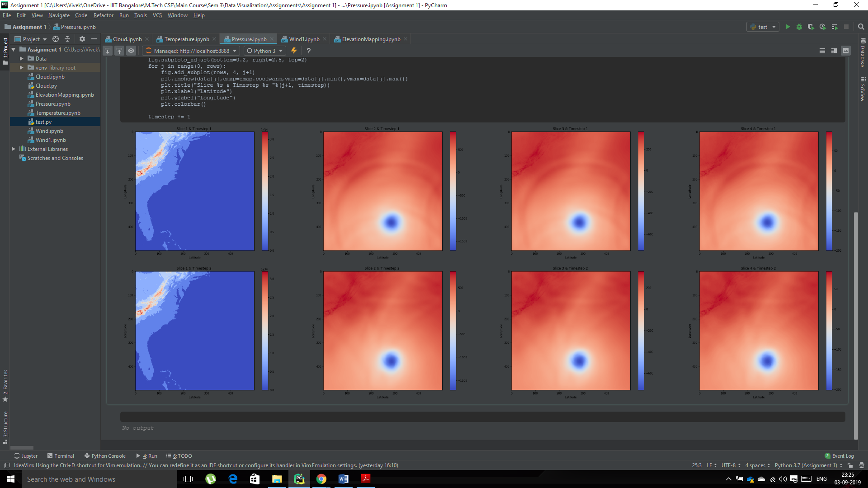

**Cloud**

The following images show the first 4 plots of the cloud data with n=1 for 2 timestamps. With higher values of n the plots were all same and no apparent change was visible.

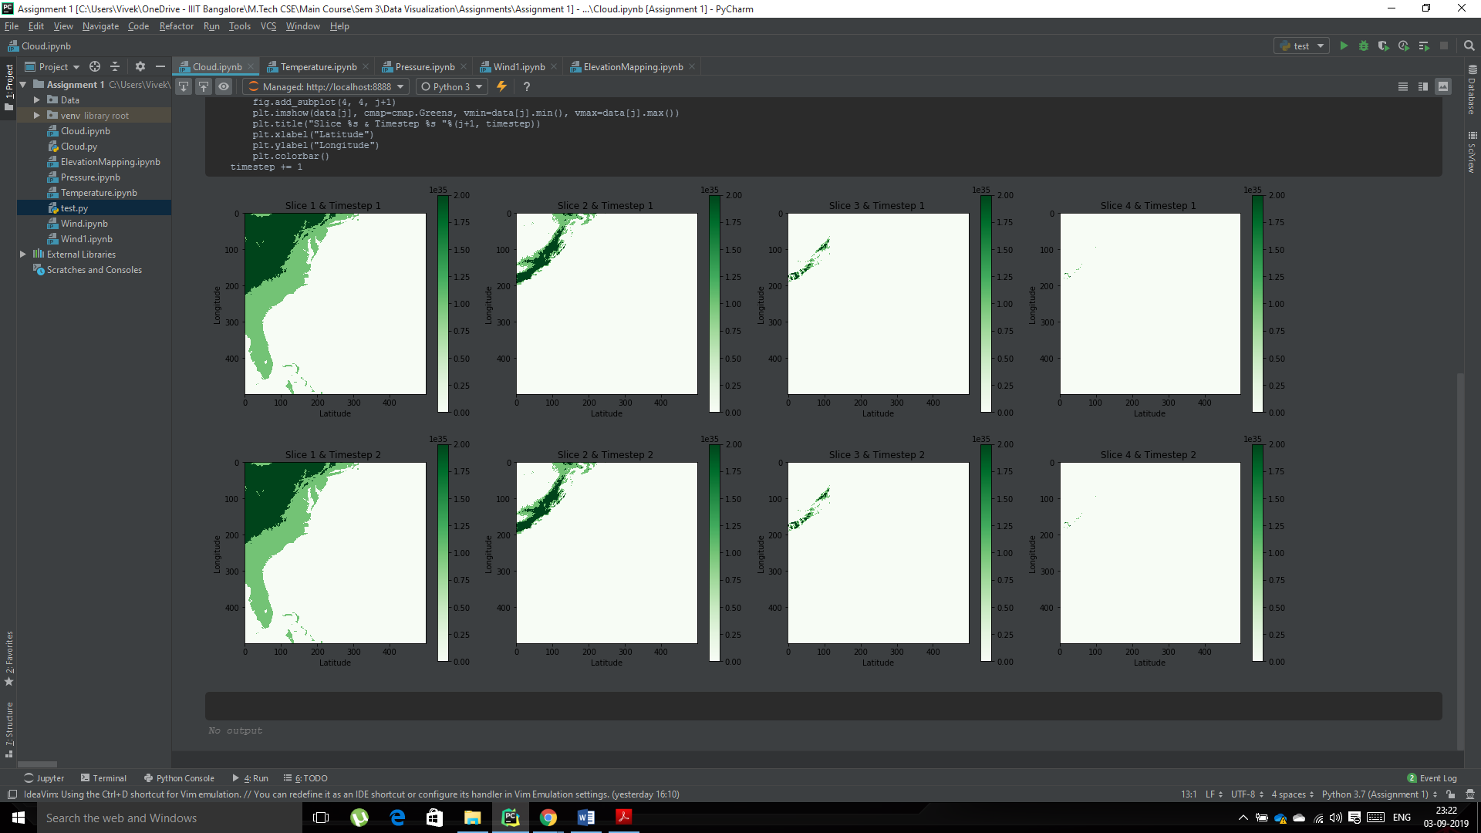

**Temperature**

The following images show the 5 plots of the temperature data with n=20 for 5 timestamps.

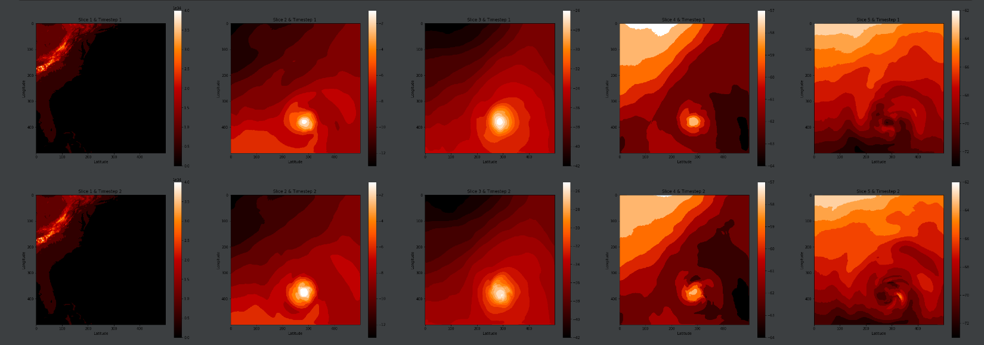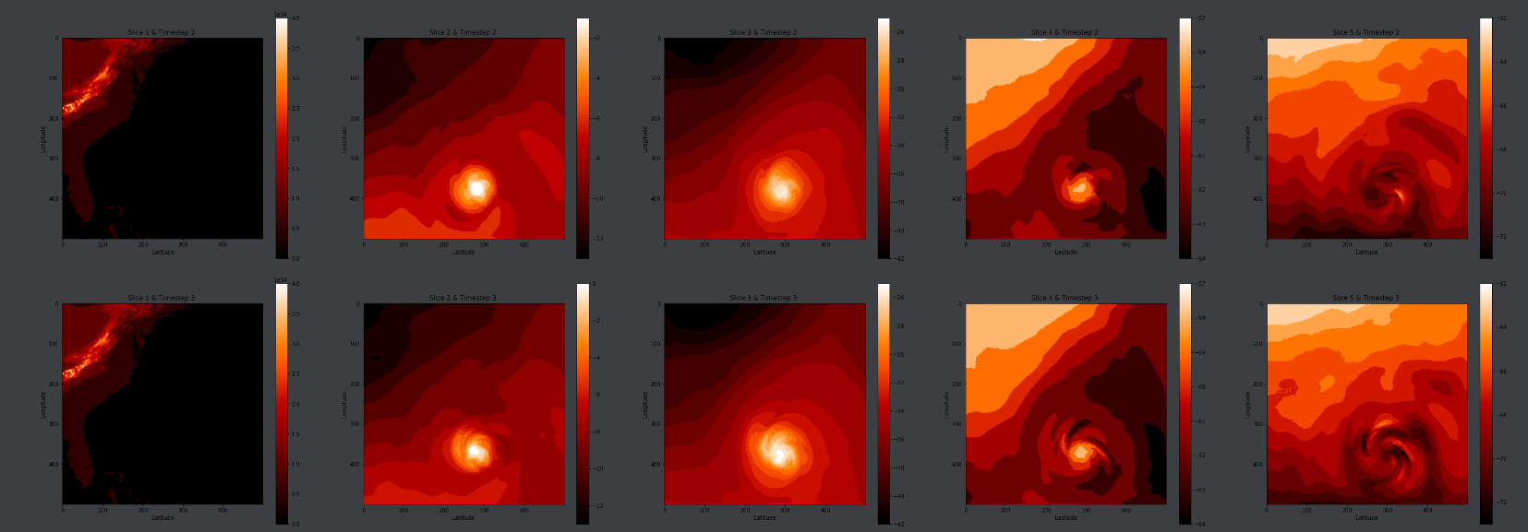 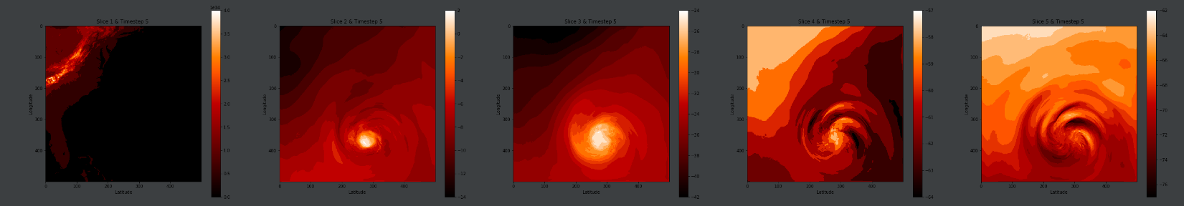

**Wind**

The following images represent the quiver plot of the wind variable for n=20.

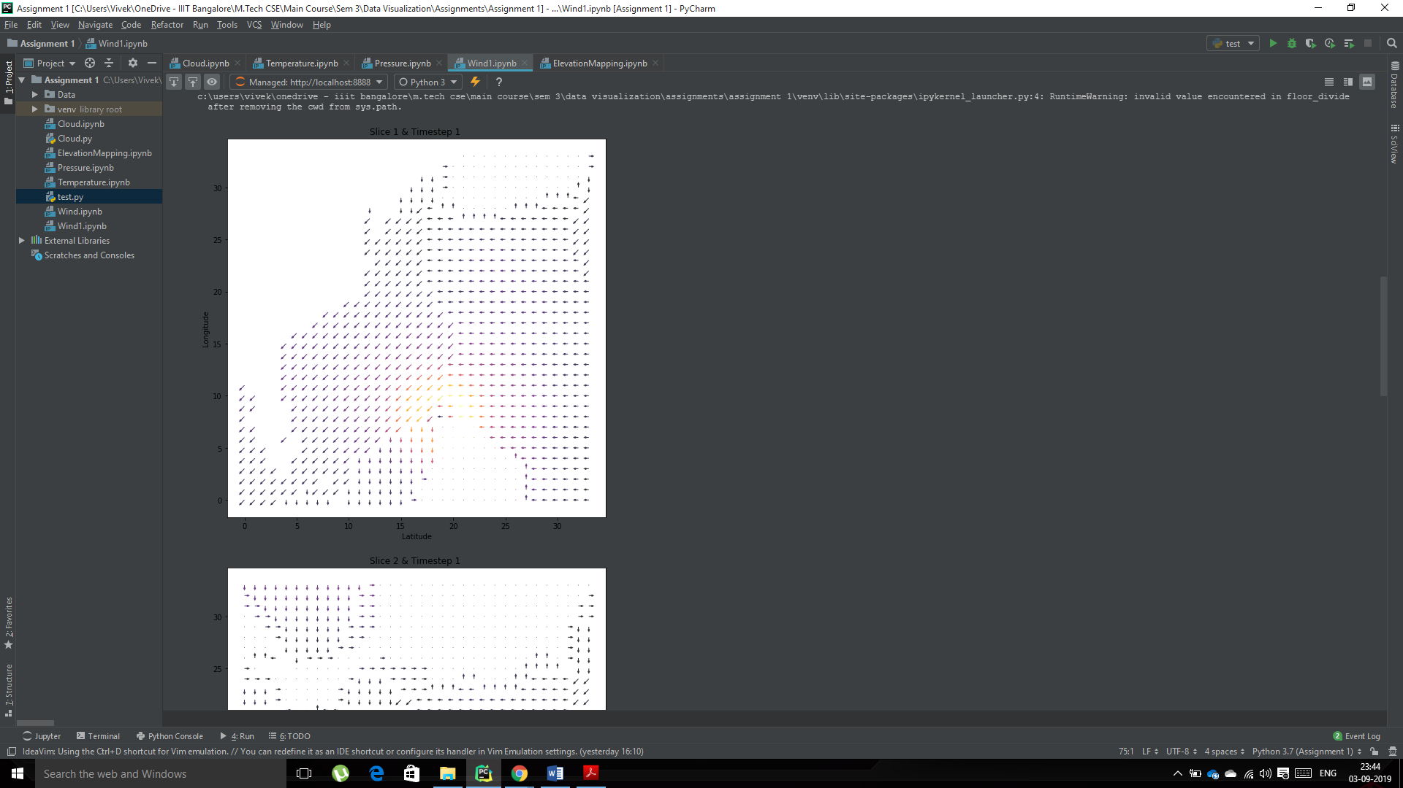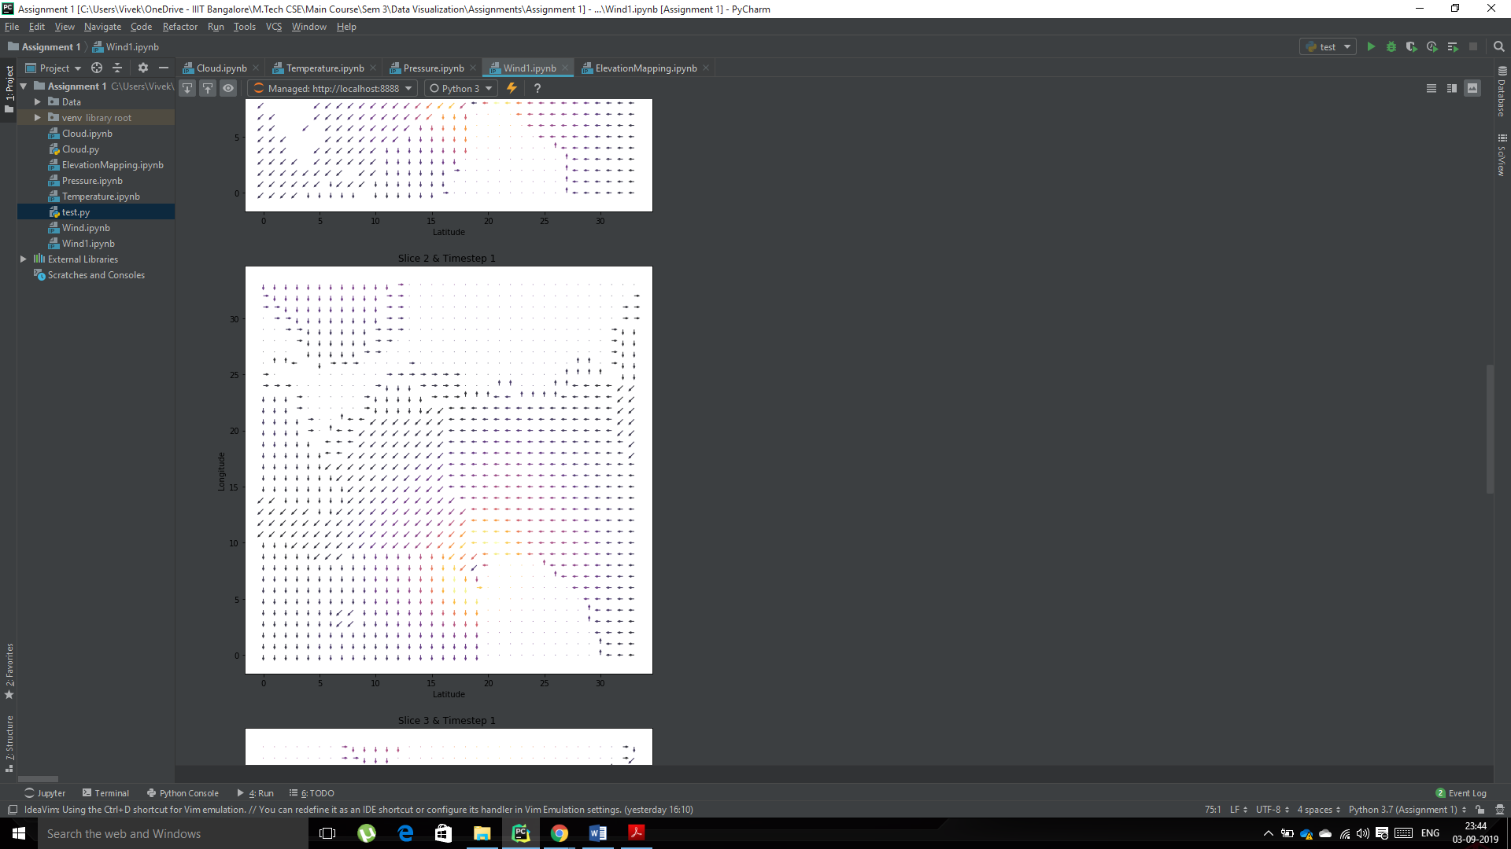

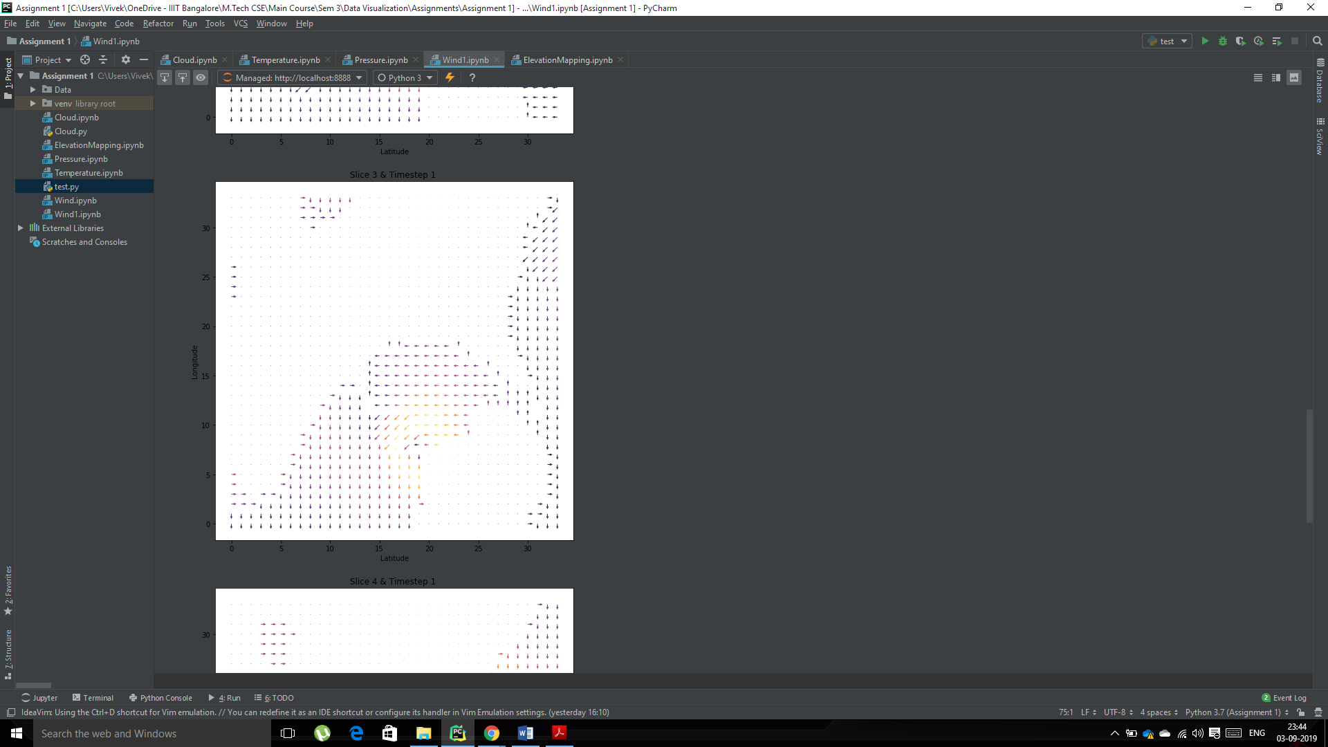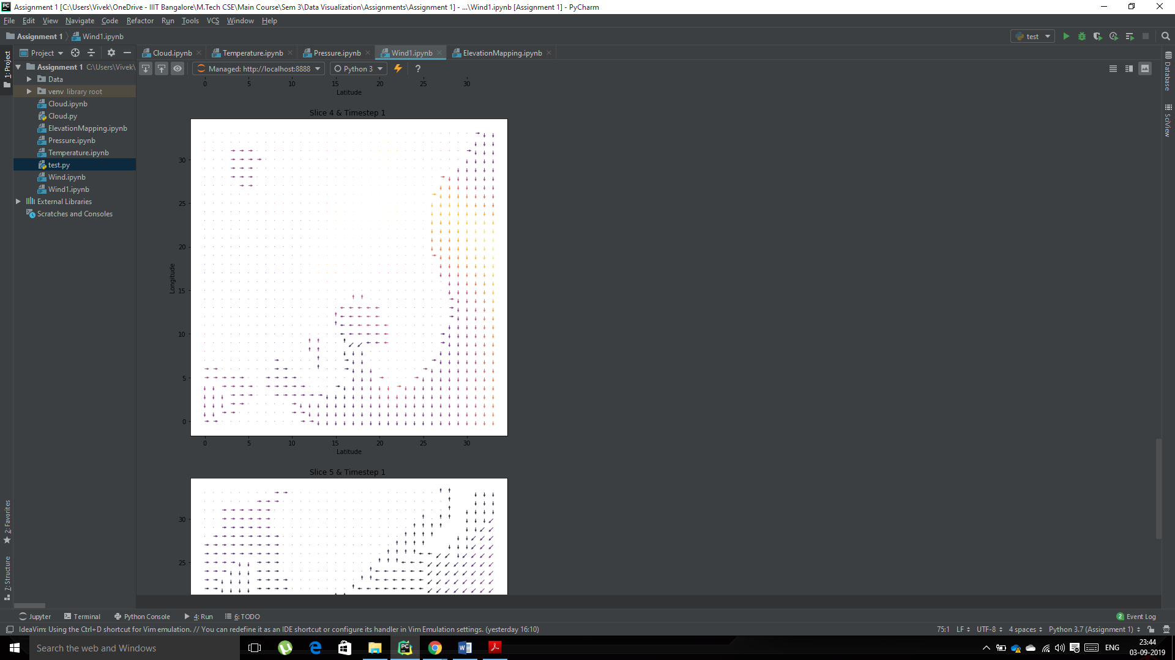

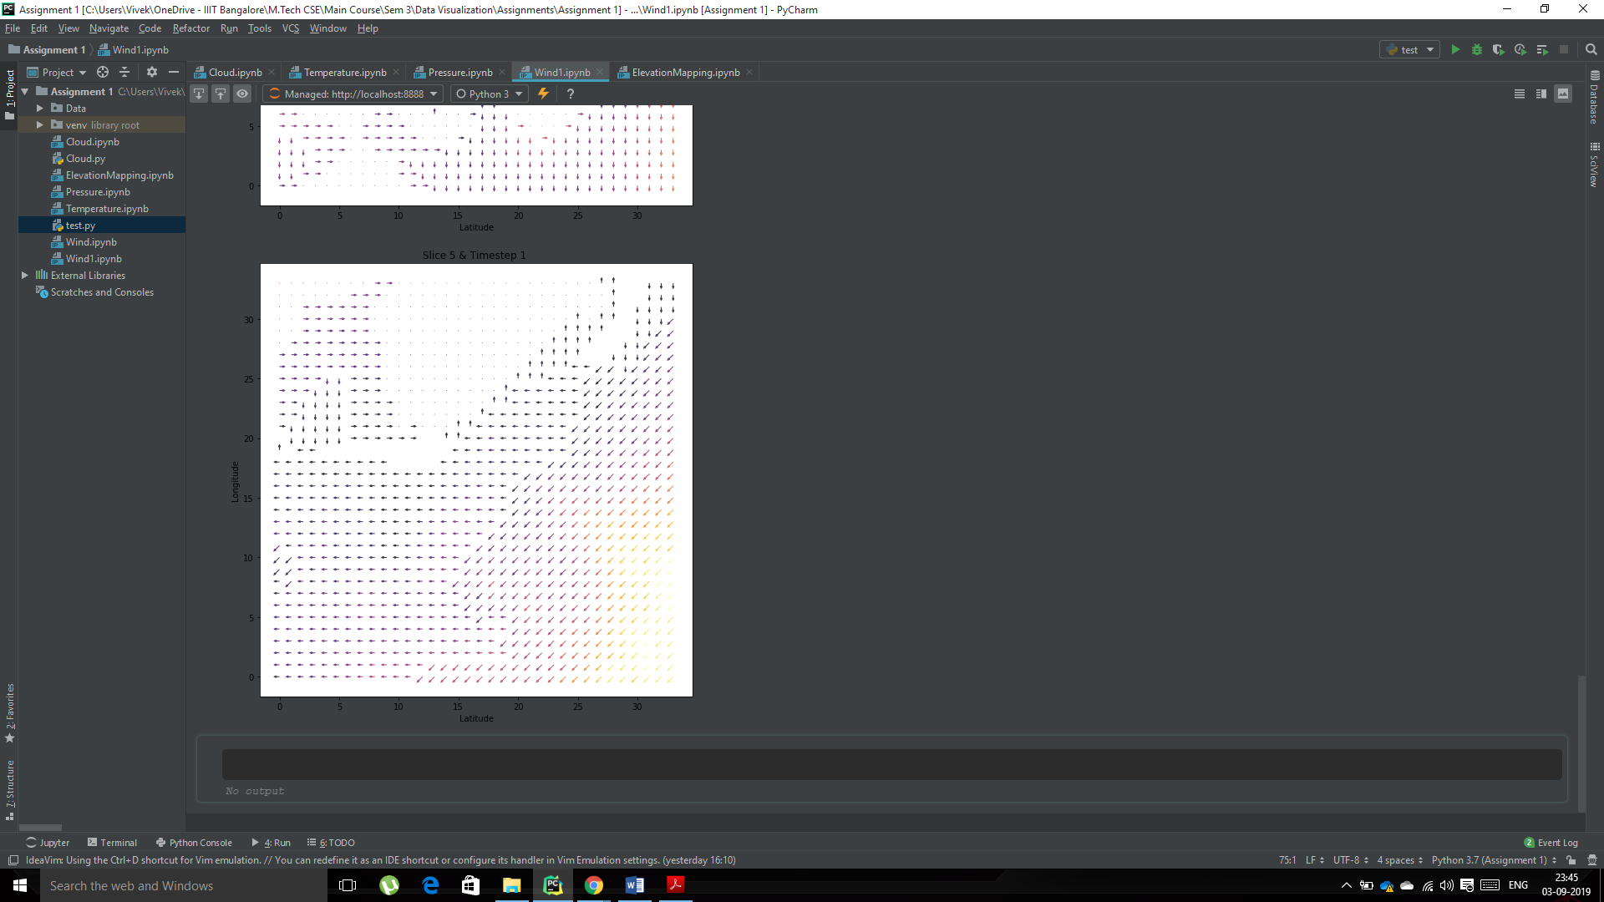

**Elevation**

